

April 29

Authored by: Jordan Lanius

Allison Flad

Jared Hunsaker

Jesse McCarville-Schueths

User Manual

Crazy Classroom

**Introduction**

The teacher has a fun lesson planned for her class, but the students aren’t listening to her. How can she grab their attention and gather them all together on the rug? Test out different toys and treats to find what brings everyone over quickest and take notes to keep track of your discoveries.

**Influencing Randomness**

The world is a wondrous place, especially in the eyes of a child. There are so many friends to talk to and colorful toys to play with. Unfortunately, that which inspires curiosity can also lead to distraction.

No teacher is truly in command of their classroom. They cannot control what their students do. However, many have discovered that using certain items and actions can help influence their class to focus on the task at hand.

*“I never teach my pupils. I only attempt to provide the conditions in which they can learn.”*

*Albert Einstein*

This simulation game will help your students understand the concept of randomness and how outside forces can influence random actions.

**Getting Started**

**Simulating the Classroom**

Every mode of this game involves the use of a classroom simulation. Children will wander around the room in a randomized path. The goal of the game is to gather all the children together on the specified rug. Players can achieve this by using items and actions called Attractors. The simulated children have a randomized attraction to these stimuli and are drawn towards the rug. Then players are encouraged to analyze the time it takes for the children to gather using each attractor.

**Choosing the Game Mode**

Choose between three exciting game modes: Beginner, Intermediate, and Advanced. Select the mode you want to play and press ***START*** to begin the game.

* ***Beginner*** is designed for Kindergarten through 2nd grade.
* ***Intermediate*** is designed for 3rd through 5th grade.
* ***Advanced*** is designed for 6th through 8th grade.

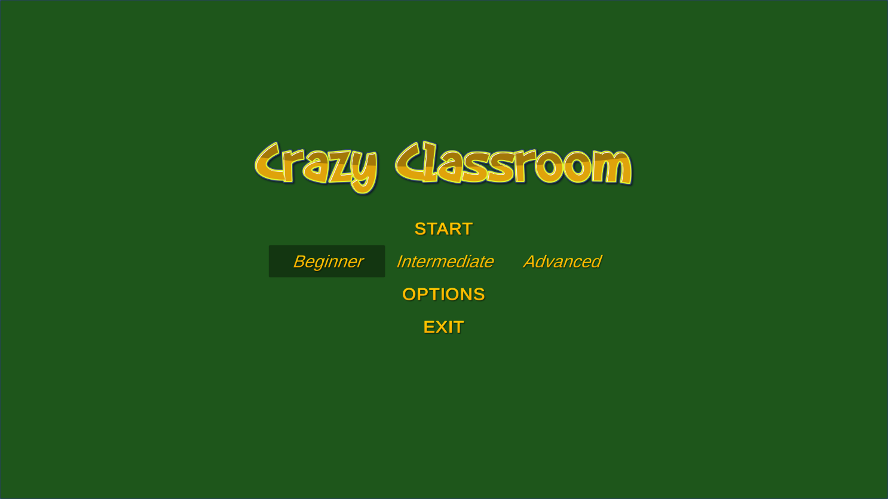While the modes are designed around grade levels, not every student is the same. Teachers are encouraged to start their students at a level that best matches their proficiencies. It may even be beneficial to work up from beginner regardless of how old the student is.

1. **Beginner**

Students will be presented with a ***Classroom Window*** and an ***Attractor Menu***. They can select an attractor from the ***Attractor Menu*** and it will appear in the ***Classroom Window*** and then press the ***Start Button*** to begin the simulation.

After running a simulation, the game will add the time it took the class to assemble to the ***Time List***. Once all simulations have been run, students will be asked basic questions about the results.

1. **Intermediate**

Students will be presented with a ***Classroom Window*** and an ***Attractor Menu***. They can select an attractor from the ***Attractor Menu*** and it will appear in the ***Classroom Window*** and then press the ***Start Button*** to begin the simulation.

Students will also be able to view how much interest the class has for each attractor. This will be displayed when hovering over an attractor in the ***Attractor Menu*** as a five-star rating.

After running a simulation, the game will add the time it took the class to assemble to the ***Time List***. Once all simulations have been run, students will be asked basic questions about the results.

At any point, students can press the ***Graph Button*** to access the ***Graph Window***. This window displays a graph of the tested attractors’ interest levels and the time they took to attract all the children. The **Classroom Button** can then be pressed to return to the **Classroom Window**.

1. **Advanced**

Students will be presented with a ***Classroom Window*** and an ***Attractor Menu***. They can select an attractor from the ***Attractor Menu*** and it will appear in the ***Classroom Window*** and then press the ***Start Button*** to begin the simulation.

Students will also be able to view how much interest each student has for different types of attractors. This will be displayed when hovering over a student in the ***Classroom Window*** as a five-star rating.

After running a simulation, the game will add the time it took the class to assemble to the ***Time List***. Once all simulations have been run, students will be asked basic questions about the results.

At any point, students can press the ***Graph Button*** to access the ***Graph Window***. This window displays a graph of the tested attractors’ interest levels and the time they took to attract all the children. The ***Classroom Button*** can then be pressed to return to the ***Classroom Window***.

**Options**

Sound is a major aspect of Crazy Classroom. An ***Options Menu*** can be accessed by pressing the ***Options Button*** where volume and ***Voice-Over*** settings can be adjusted.

**Features**

**Voice-Over**

Voice-overs are used to provide quick exposition, tell stories, narrate, and provide an intimate look into the mind of a character. For this game, a voice-over will be used to help those who are still learning to read. All prompts will be read out loud. This setting is automatically ON, but an option will be provided to turn it OFF for those who are not in need of assistance.

**Classroom Window**

The Classroom Window displays a top-down view of the classroom. This is where the children will be wandering around looking for something interesting. Based on complexity level, some additional information about the children may be visible here.

**Level Selector**

The Level Selector allows the teacher to select the complexity level. Higher complexity will increase the options and interaction for the users, introducing more factors for how the students roam.

**Attractors**

Attractors are the various toys and games that entice children to spots in the room. Higher complexity levels will add more factors to how attraction is calculates. Attractors can be found in the Attractor Menu.

**Start Button**

Once all the attractors are selected, hitting the Start Button will begin the simulation. The simulation will end once all kids have gathered in the designated areas.

**Menu Button**

The Menu Button returns the player to the main menu.

**Time List**

The times for completed simulation runs are kept in the Time List. Students will be able to compare results for different iterations of the simulation here.

**Graph Window**

Higher complexity levels will allow for the Time List to be visually represented by a graph. This will pop up over the Classroom Window.